 **8 Nov 2014** **The Weekly Bulletin of Rotary Club of Kathmandu Mid-Town** **bc-18/11.014**

|  |
| --- |
|  |

District: 3292 Web:www.rotarymidtown.org.np Club Id: 26776

**NOVEMBER IS THE ROTARY FOUNDATIO N MONTH**



**Celebrating**

**25 Years in Rotary**



**On the Occasion of 25th Charter Day Celebration:**

**The Club has served the humanity for last 25 years by providing a variety of free services to innumerable beneficiaries.**

**The Charter members of the club have been providing their time, money, professional services, and attending meetings every week of these 25 years of voluntary service!**

**We wholeheartedly thank you all Charter members on this Occasion!**

**Thank you ! Thank you !! Thank you !!!**



Club’s Regular Weekly Meeting : Friday, 31 October :

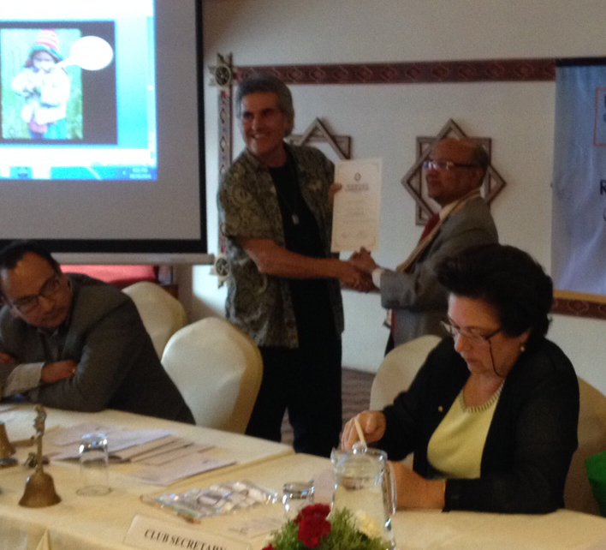

Pres Kul handing over letter of appreciation to guest speaker Tom

Regular weekly meeting # 1252 of the Club was held on Friday morning at Hotel

De l’ Annapurna.

Extracts of the Meeting Minutes # 1252 are given below:

“6. A short talk by Tom Wagner on Passive Solar Greenhouses in High Altitude Villages

of Nepal. The speaker was introduced by PP William. Mr Wagner explained that some

of the problems in Nepal (especially at high altitudes) were malnutrition, low income, low

literacy, no social services, no medical services and that these could be to some extent

rectified farmers at high altitudes could adopt passive solar greenhouses to grow veg-

etables as a cash crop. These greenhouses are a low-tech, appropriate technology that

uses low cost, local materials, local labor. PP Giri gave the vote of thanks.

“7. Information sharing/AOB:

- The Rotary Club of Itahari is organizing a “Inter Rota Badminton Tournament Nepal-Bhutan” on 31st Oct and 1st Nov 2014 at the clean, green and beautiful city Itahari. Anyone interested in participating pls contact tournament coordinator : Rtn Suresh Karki at Mobile: +977-9852048747 or Email- [karkisuresh632@gmail.com](mailto:karkisuresh632@gmail.com) or [rotaryclubanita@gmail.com](mailto:rotaryclubanita@gmail.com)

- Rotary South Asia Conference on Peace during 6-9 February 2015 in Lumbini, Nepal.

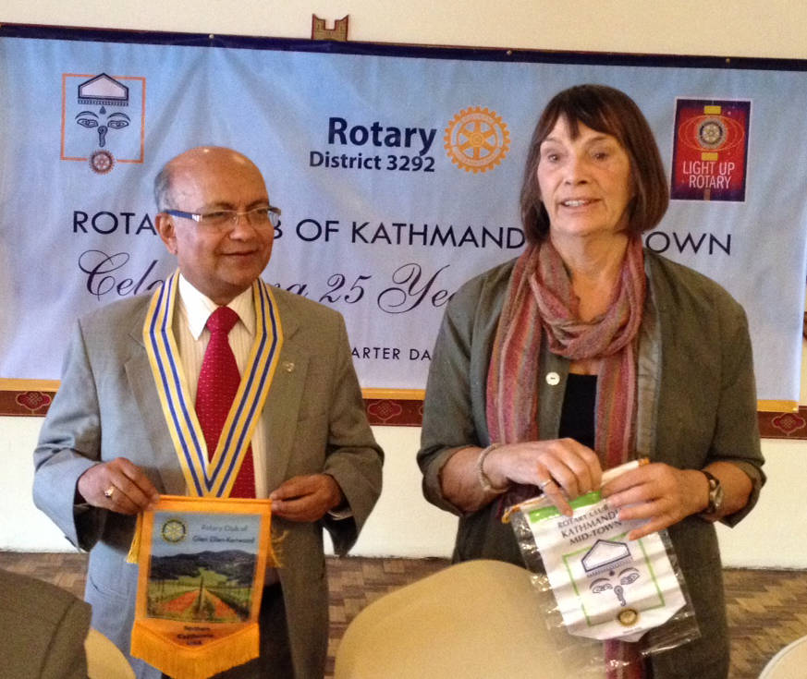

Exchanging club banners

- Ranta Man Sakya, Chair, Nepal National PolioPlus Committee tells us that: Your gift to

PolioPlus is eligible for Paul Harris / Society recognition. Your $5 donation is matched 2

to 1 by the Bill and Melinda Gates Foundation, turning your $5 into $15 to fight Polio. Also

note that this year there will be a switch from the oral polio vaccine and introduction of

IPV (Inactive or Injectable Polio Vaccine).

- The Gopal and Kamala Rajbhandari Rotary Award for Vocational Excellence This year

the committee has decided to grant award in the field of Art and Culture. Please send

nomination to the Rotary District Secretariat in Thapathali, care of Rtn. Diwakar Rajkarnikar

(Chair, District Vocational Award Extended Committee) before 15th December 2014.

- ROTA QUIZ: You are kindly requested to volunteer for the Rota Quiz Team. We will need a team of 4 with and a team leaders as well as stand by candidates. Names of volunteers needed before the end of October 2014.

“8. Pres Kul shared information on the upcoming 25th Charter Day Celebration planned for Nov 8, 2014 at the Hotel de l’ Ànnapurna. He thanked Rtn Asko for having helped to arrange the visit of Pres Halonen and Pres Ramos-Horta. This visit of two former presidents to our club will indeed be a very historical event.

“9. A wrap-up visit is being planned for the ANM Project. Please contact PP CK Golchha for details of the trip to Rara Lake and sign-up sheet.

“10. Exchange of flags with Rtn Carol Vernal of the Rotary Club of Glen Ellen-Kenwood in Northern California.

“11. Statistics of the meeting: Members present: 29 ”

# Weekly Meetings and Programs :

|  |  |  |
| --- | --- | --- |
| Date | Program/Speaker | Topic of Presentation |
| 8 November | Charter Day Celebration | Charter Day Celebration |
| 14 November |  |  |
|  |  |  |
|  |  |  |

**CHARTER DAY CELEBRATION**

Saturday, 8 Nov 2014

The Rotary Club of Kathmandu Mid-Town celebrates its 25th Charter Day with a meeting and cocktail dinner on the evening of Saturday, 8 November 2014.

Come and join us to help celebrate our historic 25 years in Rotary. We are going to welcome and witness two special Guest speakers in our historic Charter Day celebration: they are the members of the prestigious Club de Madrid - former President Tarja Halonen (Republic of Finland) and the Nobel Peace Prize winner and former President Ramos-Horta (Democratic Republic of Timor-Leste). The two notable dignitaries, who are in Kathmandu leading a high-level mission to Nepal with the noble objective of fostering: ***‘women as agents of change in building shared societies in Nepal’*** have kindly consented to grace the occasion. These two leaders have much to say that is relevant to Nepal; they will be sharing with us their views on women as agents of change and how national and international service organizations like Rotary can play a constructive role in women's empowerment.

Program highlights:

17:30 hrs Registration and fellowship at Arch Room, Hotel del’ Annapurna

18:00 hrs All seated

18:00-18:45 Regular Club meeting # 1253

Dignitaries on the dais: Pres Kul C Gautam; DG Rabindra Piya; PDG Yogendra Man Pradan,

Charter President Roop Jyoti, and Secretary Isabella CB Khadka

Meeting #1253 Called to Order by President Kul C Gautam

President Kul welcomes Rotary dignitaries and guests, *khada* and bouquet to Rotary dignitaries;

Lighting the lamp by DG Rabindra Piya;

President Kul honors the Charter Members: *khada* and bouquet to Charter President and

Charter members and their spouses;

A few words by Charter President Dr Roop Jyoti on 25 years in Rotary service;

DG Rabindra Piya presents mementos of recognition to Charter Members;

A toast by all Past Presidents of the Club on the happy occasion of 'Celebrating 25 Years in Rotary':

the toast will be proposed jointly by CP Dr Roop and Pres Kul; all PP’s will partake in it by clapping.

18:45 hrs Adjournment of Club meeting:

18:45 – 19:00 Assemble at Poolside for second part of the Program;

19:00 hrs A champagne welcome for our guests;

19:25 hrs A few remarks by President Kul;

19:30 hrs A few words on 'Women and Rotary in Nepal' by PP Ambica Shrestha (Nepal’s first female Rotary President);

19:35 hrs A few remarks by our two guests: President Tarja Halonen and President José Manuel Ramos-Horta;

19:55 hrs The two guests honor Charter President Dr Roop Jyoti;

19:58 hrs Ceremonial cutting of 25th Anniversary cake;

20:00 hrs Cocktails and dinner.

**ACT ASIA – INTERNATIONAL INTERACTOR'S CONFERENCE**

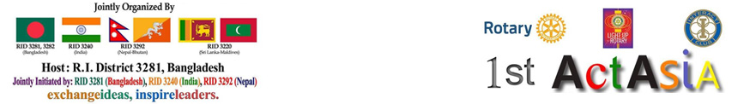

ACT ASIA comprises of a joint meet of interactors from all over the world , so as to unite and serve to the aims and goals of the Rotary International. It aims to unleash a leader in interactors through various trainings while also strengthening their sportsmanship, communicativea nd various interpersonal skills. Its major aim is to increase fellowship between these like minded youth and establishing a base for them to carry out numerous future collaborations internationally. As the name says, it symbolizes ” action” starting from Asia. The event is a joint model of a traditional RYLA with additional entertainment and a platform for cultural exchange, adventures, networking and a hall of fame for various life changing impacts brought by participating districts in their community. The event is carried out by Interactors with Mentorship from Rotaractors and Rotarians.

**Act Asia 2014**, the 4-day Mega event is scheduled to be held 19 – 22 December 2014 at the CSS AVA CENTRE, Khulna, Bangladesh

The District Interact Council 3292 cordially invites you to take part in our 4 day mega event "Act-Asia 2014"

For details please refer to invitation letter from Interact District Council 3292 given in Annex ‘A’

**On the Occasion of World Polio Day on 24 October**



Rotarian friends, do you want to make your $ 5 into $ 15 to fight Polio?

Here is a simple formula !

Your gift to PolioPlus is eligible for Paul Harris / Society recognition. Your $5 donation is matched 2 to 1 by the Bill and Melinda Gates Foundation, turning your $5 into $15 to fight Polio.

For more details, please refer and go through a call made by PDG Ratna Man Sakya, Chair, Nepal National PolioPlus Committee, given in annex ‘B’.

**RI club invoice process being changed/improved**

Rotary International introduces new club invoice process effective from January 2015.

The clubs are required to ensure keeping member list current in Rotary International’s database by 1 January.

The accuracy of club invoice will depend on the accuracy of the clubs’ members information.

Club secretaries are responsible for updating member lists every 30 days or as changes occur, by 1 July and 1 January at the very latest. They are also responsible for reporting incoming club officers by 1 February of each year.

For more details, refer to RI General Secretary John Hewko’s letter given in annex ‘C’

**Rota Badminton Tournament Nepal-Bhutan 3292**

**Rotary Club of Itahari** organized “Rota Badminton Tournament Nepal-Bhutan 3292” on 31st Oct 2014 at clean, green and beautiful city Itahari.

Eleven different clubs of RI District 3292 took part in the tournament and more than hundred Rotarians were together for fellowship.

Game was divided into Mans double, Mans single and Veteran.

The main sponsor of the Tournament was BIG MASTER WINE, product of Royal Kathmandu Himalaya Beverage pvt. Ltd.

**Committee Chairs’ Column:** *(This column is for use by chairpersons of 5 permanent committees: Club Administration, Membership, Public Relations, Service Projects, and the Rotary Foundation)*

On Lighter Side :



Great Quotes :





**A THOUGHT FOR TODAY:**

"How much damage is done every day as a result of the deplorable tendency of always finding something negative to gossip about in others!

And newspapers, the radio and the television only amplify this tendency.

What pleasure can there be in focusing so much on what is ridiculous, stupid or nasty?

How can it be of interest to dig about in people’s personal lives in search of shocking details and then to disclose them for public amusement?

It may seem of no importance, but it is an increasing tendency, and in the end it undermines a society,

because it rubs off on the whole population.

People vie to point out details, which they then exaggerate or distort, choosing the cruellest words to spread their gossip. Everyone has something reprehensible or ridiculous about them – that is nothing new – but why dwell on it at length? Society will not be any better for it.

A sage tries to have a different attitude.

He is not blind; he is even very lucid, and is also capable of criticizing and making fun, but he considers that the most important thing about people is their qualities and their virtues.

So these are what he focuses on, and with this attitude he reinforces the good in other people and in himself.

By working in this way, he is being constructive."

*Omraam Mikhaël Aïvanhov*

*Source: Internet News*

**Members’ Corner:** *(This column is for Club members to express anything they would like in matter of Club activities, Club administration, Club issues or on Breakfast Chatter, or on anything else that would be of interest to fellow members.)*

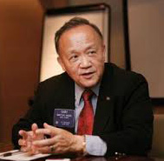

Rotary is built of service: Each project is another brick in the big building that is Rotary. If

our service forms the bricks, then there is no question that friendship is the mortar that

holds those bricks together.

**RI President GARY C.K. HUANG**

Please send information on club activities, progress reviews on service projects, relevant photos etc to:

BC Editor: RR Shrestha email: rryesrr@gmail.com

## 8 November 2014 The Weekly Bulletin of Rotary Club of Kathmandu Mid-Town bc-18/11.014

*Annex ‘A’*

**INTERACT DISTRICT COUNCIL**

**RI DISTRICT 3292**

Date: 15-10-2014

Dear Respected Rotarian/Rotaractor/Interactor/RCC

**INVITATION TO PARTICIPATE IN "ACT ASIA – INTERNATIONAL INTERACTOR'S CONFERENCE"**

The District Interact Council 3292 cordially invites you to take part in our 4 day mega event "Act-Asia" at the CSS AVA CENTRE, Khulna, Bangladesh being held from 19th through the 22nd of December 2014. Act Asia is the realization of the importance of initiatives Rotarians have taken. It is the celebration of the difference we've made and the promotion of what we can do further in our respective areas of the world, one small step at a time. It is an attempt to establish Interact as a happy medium between a social club and a service club, to provide our young change makers an opportunity to harness life changing interpersonal skills.

For 4 days this council in partnership with the Interact District Council 3281 (Bangladesh), 3240 (North India) and 3220 (Sri Lanka and Maldives) will be hosting more than six hundred Interactors, Rotaractors and Rotarians in an attempt to encourage them and to provide them with new insights in serving the world.

The event will feature various cultural shows, service work presentations, laser shows and speakers from Malaysia, Pakistan, India and Nepal. It also features an exciting and adventurous cruise to Sundarban (one of the few tiger habitats and the largest mangrove forest in the world). We also have very affordable Post Conference tour packages to 'Pokhara' of Nepal and 'Darjeeling of India' at just 130$ per person including food accommodation and travel to destination which will be entirely guided and carried our by local Rotaractors. We have invited hundreds of change makers from all over the world and we look forward to you for being one of them in learning something new and cherishing Rotary at the same time.

The District Interact Council 3292 is the guardian of the 82 plus Interact Clubs (the Youth wing of the Rotary International) in Nepal and Bhutan. It has initiated this-first of its kind- event in partnership with other District councils in Asia last December. Your club has been of great motivation in your community and your attendance will further enhance the prospect of this event and oblige our council. Therefore, we humbly invite you in this conference.

As organizers we would be happy to host you in the event and the cruise and waive your registration fees.

To confirm your attendance or for further details please visit [www.actasia2014.com](http://www.actasia2014.com) or contact me at [registration@actasia2014.com](mailto:registration@actasia2014.com)

Thank you for your time and consideration

Yours sincerely,

Itr.Rabina Shakya

District Secretary

Interact District Council 3292, Nepal & Bhutan

Registrations Chair, Act Asia

*Annex ‘B’*

NEPAL NATIONAL POLIOPLUS COMMITTEE



Dear Fellow Rotarians,

Wishing you and your family a very Happy & Prosperous Deepawali and Happy New Year

Nepa Sambat 1135.

To-day October 24 is also World Polio Day which is being celebrated by many clubs across the

world, either individually or jointly. There are many ways you could mark the day. You can

participate in local FM talk shows. FM is the most influential sources of information among

mass media sources. Press release or Flyer on key messages as there will be a switch from

tOPV to bopv (Oral vaccines) to Injectable Polio Vaccine. Thereafter the removal of Oral polio

vaccine and introduction of IPV (Inactive or Injectable Polio Vaccine).

Nepal National PolioPLus Committee is organizing orientation program together with WHO,

UNICEF, Government to health workers and volunteers, Rotarians and Retractors. If your club or group of clubs in your area wants to host this orientation program without much cost to host clubs, please let me know, we will try to have the program in your area.

Remember: Your gift to PolioPlus is eligible for Paul Harris / Society recognition. Your $5 donation is matched 2 to 1 by the Bill and Melinda Gates Foundation, turning your $5 into $15 to fight Polio.

We are all busy, but the children around the world need us.  Imagine all the children who will be able to walk, play and dance, because we joined together to remember them.

As Rotarians we are able change lives of people around the world that we would normally ever meet.  It truly is amazing. We promised the children of the world that we would eradicate polio, and Rotarians keep their word.

Sincerely,

Ratna Man Sakya

Chair, Nepal National PolioPlus Committee.

*Annex ‘C’*



**John P. Hewko,** General Secretary

[T +1.847.866.3431](tel:1.847.866.3025), [F +1.847.556.2198](tel:1.847.866.3390)

[general.secretary@rotary.org](mailto:general.secretary@rotary.org)

Dear Club Officer,

By now you have heard about the new club invoice that’s coming this January. The invoice will arrive ready to be paid, so please be sure your member lists are current in Rotary International’s database by 1 January. No adjustments will be made.

**WHAT’S IN IT FOR ME?**

Instead of receiving a packet, you will receive a simple, 1-page invoice clearly stating what you owe. You no longer need to calculate your invoice, which saves you time. In fact, you will not be able to make adjustments after receiving your invoice. Keeping your records current will enable you to see your club’s progress on its membership goals each month.

**HOW DOES IT AFFECT ME?** The biggest change for club officers is that it will be even more important to keep your club’s membership information current in Rotary’s database. The accuracy of your invoice will depend on the accuracy of that information. Club secretaries are responsible for updating member lists every 30 days or as changes occur, by 1 July and 1 January at the very latest. They are also responsible for reporting incoming club officers by 1 February of each year.

The change to the club invoice process also means that the information in your officer manuals is incorrect. This [document](http://echo4.bluehornet.com/ct/49555593:28273299646:m:1:1003262935:E354E554E9BA0EB321D380E39BD6027D:r)explains the new policy.

**What can I do to get ready?**

□        Make sure you have a [Rotary.org](http://rotary.org/) account. Help other officers [create](http://echo4.bluehornet.com/ct/49555595:28273299646:m:1:1003262935:E354E554E9BA0EB321D380E39BD6027D:r) one if they don’t already have

one. Contact your [Club and District Support representative](http://echo4.bluehornet.com/ct/49555596:28273299646:m:1:1003262935:E354E554E9BA0EB321D380E39BD6027D:r) or [local Rotary office](http://echo4.bluehornet.com/ct/49555597:28273299646:m:1:1003262935:E354E554E9BA0EB321D380E39BD6027D:r) for support.

□       Learn how to [update your member lists](http://echo4.bluehornet.com/ct/49555598:28273299646:m:1:1003262935:E354E554E9BA0EB321D380E39BD6027D:r) and pay club invoices through [Rotary.org](http://rotary.org/).

·         [How to add a member](http://echo4.bluehornet.com/ct/49555599:28273299646:m:1:1003262935:E354E554E9BA0EB321D380E39BD6027D:r)

·         [How to edit member information](http://echo4.bluehornet.com/ct/49555600:28273299646:m:1:1003262935:E354E554E9BA0EB321D380E39BD6027D:r)

·         [How to remove a member](http://echo4.bluehornet.com/ct/49555601:28273299646:m:1:1003262935:E354E554E9BA0EB321D380E39BD6027D:r)

·         [How to Pay Your Invoice](http://echo4.bluehornet.com/ct/49555602:28273299646:m:1:1003262935:E354E554E9BA0EB321D380E39BD6027D:r)

·         [How to Add an Officer](http://echo4.bluehornet.com/ct/49555604:28273299646:m:1:1003262935:E354E554E9BA0EB321D380E39BD6027D:r)

□        If you report membership changes using a [local database or software provider](http://echo4.bluehornet.com/ct/49555605:28273299646:m:1:1003262935:E354E554E9BA0EB321D380E39BD6027D:r), check with the

software provider to make sure it is submitting your information to Rotary’s database.

□        Make sure your club secretary is prepared to update membership lists as changes occur and by

1 January and 1 July.

□        Learn more at [www.rotary.org/clubinvoice](http://www.rotary.org/clubinvoice).

□        Save a tree and select the [paperless](http://echo4.bluehornet.com/ct/49555607:28273299646:m:1:1003262935:E354E554E9BA0EB321D380E39BD6027D:r) invoice option. The new streamlined process is both

environmentally and economically sound.

**OFFLINE OPTIONS**

We recognize that not all Rotarians are able to report membership changes online.

You can also complete the [Member Data Form](http://echo4.bluehornet.com/ct/49555608:28273299646:m:1:1003262935:E354E554E9BA0EB321D380E39BD6027D:r) and:

·          Email it to  [data@rotary.org](mailto:data@rotary.org)

·       Fax it to [+1-847-556-2207](tel:%2B1-847-556-2207)

·       Mail it to your local Rotary office or fiscal agent.

Rotary staff worldwide is working hard to give you tools that make your job as a club officer easier. I hope you find this new process beneficial and efficient.

Sincerely,

John Hewko, General Secretary

Rotary International

[ONE ROTARY CENTER](http://echo4.bluehornet.com/ct/49555592:28273299646:m:1:1003262935:E354E554E9BA0EB321D380E39BD6027D:r),

[1560 SHERMAN AVENUE](http://echo4.bluehornet.com/ct/49555592:28273299646:m:1:1003262935:E354E554E9BA0EB321D380E39BD6027D:r),

[EVANSTON, ILLINOIS 60201-3698 USA](http://echo4.bluehornet.com/ct/49555592:28273299646:m:1:1003262935:E354E554E9BA0EB321D380E39BD6027D:r), [ROTARY.ORG](http://echo4.bluehornet.com/ct/49555592:28273299646:m:1:1003262935:E354E554E9BA0EB321D380E39BD6027D:r)